DATA ANALYSIS
Efficiency calculations:
N_ref | $$σN_ref$$ | I_ref | $$σI_ref$$
33304.5 | 148.52 | 28.37 | 0.13

Day 1 and Day 2: |  | Day 3:
N_i | $$σN_i$$ | N_i | $$σN_i$$ | I_i | $$σI_i$$
4754.74 | 84.59 | 6363.96 | 100.319 | 7.53 | 0.04
11587.8 | 115.705 | 15362.8 | 134.584 | 26.57 | 0.11
421.276 | 51.06 | 667.661 | 57.608 | 3.125 | 0.014
910.91 | 63.36 | 845.467 | 67.15 | 12.97 | 0.06
1669.06 | 52.068 | 1938.36 | 58.15 | 14.63 | 0.06
887.99 | 42.45 | 1052.93 | 51.22 | 10.13 | 0.05
1283.13 | 47.27 | 1358.98 | 55.68 | 13.54 | 0.06
1738.67 | 43.16 | 2183.7 | 49.48 | 20.85 | 0.09
Table 1: Intensities and number of counts used for relative efficiency calculations
Europium Efficiencies:
 | Day 1: |  | Day 2: |  | Day 3:
Gamma energy | Efficiency | $$σEff$$ | Efficiency | $$σEff$$ | Efficiency | $$σEff$$
244.697 | 0.557184 | 0.013648 | 0.537883 | 0.0105624 | 0.552465 | 0.0099637
344.279 | 0.374191 | 0.006016 | 0.371506 | 0.0046657 | 0.377965 | 0.0045109
443.965 | 0.218429 | 0.016414 | 0.114835 | 0.0139472 | 0.139662 | 0.0121059
778.821 | 0.0943952 | 0.004872 | 0.059826 | 0.0041880 | 0.042612 | 0.0034031
964.079 | 0.0909016 | 0.003942 | 0.0971816 | 0.0031203 | 0.086162 | 0.00269
1085.87 | 0.0746734 | 0.004773 | 0.0746715 | 0.0038526 | 0.067946 | 0.0033557
1112.07 | 0.0707218 | 0.003900 | 0.0807251 | 0.0030395 | 0.002742 | 0.0027422
1408.01 | 0.0702751 | 0.002392 | 0.0710342 | 0.0018465 | 0.001649 | 0.0016497
Table 2: Europium efficiencies

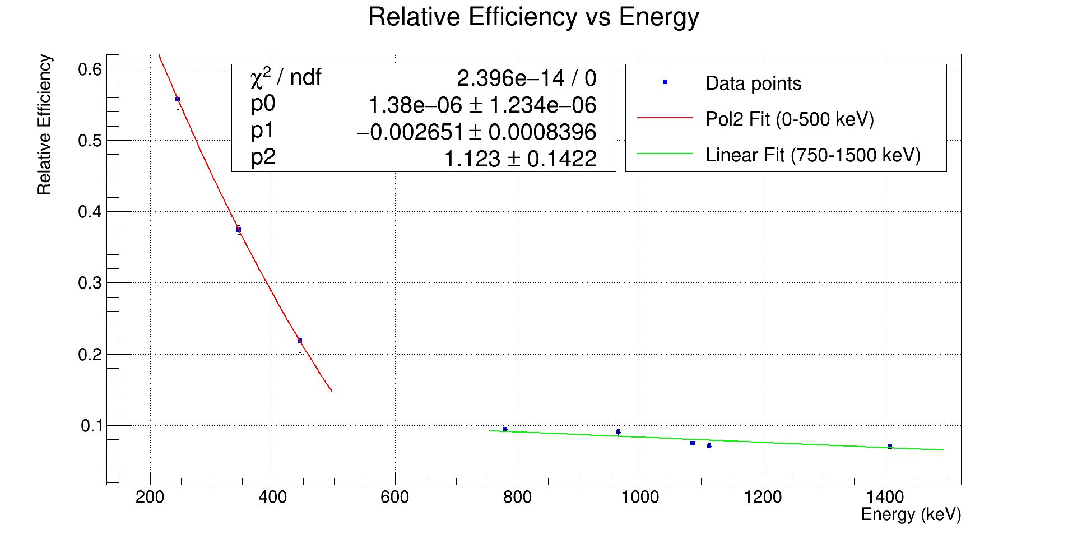
Figure 2: Efficiency fit function Day -1
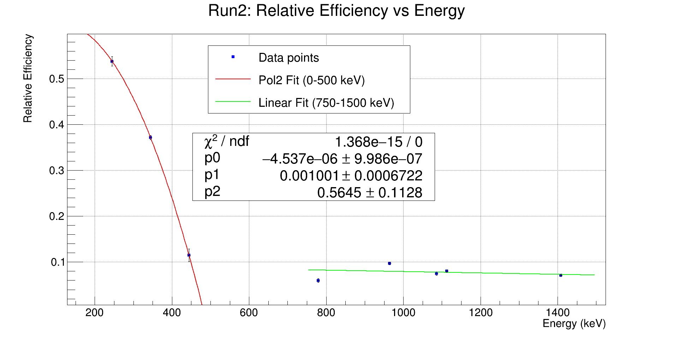
Figure 3: Efficiency fit function - Day 2
Uranium:
Decay constants:
$$λ_{235}=9.8542*{10}^{-1}$$
$$λ_{238}=1.55101*{10}^{-1}$$

Gamma energies | Number of counts | Efficiencies | Branching ratios | Decay counts | Number of atoms | Isotopic ratio
Day 1: |  |  |  |  |  | 0.00276725 +/- 0.000047
U-235 |  |  |  |  |  | 0.00276725 +/- 0.000047
185.715 | 61583.2 | 0.6784 | 57.2 +/- 9 | 1076.63 | 1.09252e12 | 0.00276725 +/- 0.000047
U-238 |  |  |  |  |  | 0.00276725 +/- 0.000047
1001.7 | 51559.6 | 0.0834 | 0.842 +/- 8 | 61234.7 | 3.94805e14 | 0.00276725 +/- 0.000047
Day 2: |  |  |  |  |  | 0.00282513 +/- 0.000030
U-235 |  |  |  |  |  | 0.00282513 +/- 0.000030
185.715 | 172023 | 0.593998 | 57.2 +/- 9 | 3007.39 | 3.05179e12 | 0.00282513 +/- 0.000030
U-238 |  |  |  |  |  | 0.00282513 +/- 0.000030
1001.7 | 141073 | 0.0792668 | 0.842 +/- 8 | 167545 | 1.08023e15 | 0.00282513 +/- 0.000030
Day 3: |  |  |  |  |  | 0.00242883 +/- 0.000032
U-235 | 112132 | 0.625868 | 57.2 +/- 9 | 1960.36 | 1.9893e12 | 0.00242883 +/- 0.000032
185.715 |  |  |  |  |  | 0.00242883 +/- 0.000032
U-238 | 107404 | 0.0664421 | 0.842 +/- 8 | 127558 | 8.22421e14 | 0.00242883 +/- 0.000032
1001.7 |  |  |  |  |  | 0.00242883 +/- 0.000032
Table 3: Uranium efficiencies and Isotopic abundance

